**Project Report: Building a Blog Application with Django Backend**

**Table of Contents**

1. Executive Summary
2. Introduction
3. Project Objectives
4. Introduction to Django
   * 4.1 Development Environment
   * 4.2 Syntax Basics
5. Object-Oriented Programming in Django
   * 5.1 Models and Views
   * 5.2 Template Rendering
6. Dependency Management
   * 6.1 Virtual Environments
   * 6.2 Project Structure
7. Working with Database
   * 7.1 Part 1: Basic CRUD Operations
   * 7.2 Part 2: Query Optimization
8. Connecting with Frontend
   * 8.1 API Endpoints
   * 8.2 JSON Handling
9. Conclusion
10. References
11. Appendices

**1. Executive Summary**

This report outlines the development of a Blog Application, focusing on its objectives, technologies employed, and outcomes achieved. Built with a Django backend, the application enables users to create, read, update, and delete blog posts and comments efficiently. The project utilizes Django's ORM for database management and templates for rendering dynamic HTML content.

**2. Introduction**

Blog applications are essential for sharing ideas, insights, and information in the digital age. They provide a platform for individuals and organizations to express their thoughts and engage with a broader audience. The motivation for creating this application stems from the need for a user-friendly interface and efficient backend handling of blog content. This project aims to deliver a robust solution that enhances user interaction and provides a responsive design.

**3. Project Objectives**

* **Full-Stack Development**: Create a comprehensive web application for blogging that includes features for managing posts and comments.
* **Template Implementation**: Develop Django templates to render dynamic content for users.
* **Responsive UI**: Ensure that the frontend is accessible and user-friendly across various devices.

**4. Introduction to Django**

**4.1 Development Environment**

It was developed using virtual environment and Django

**4.2 Syntax Basics**

Django based on Python, utilizing its syntax

**5. Object-Oriented Programming in Django**

**5.1 Models and Views**

In Django, models represent the data structure of the application. For the blog application, the models might include User, Post, and Comment.

5.2 Template Rendering

A templating engine was used to render HTML pages. For instance, a simple template for displaying posts could look like this:

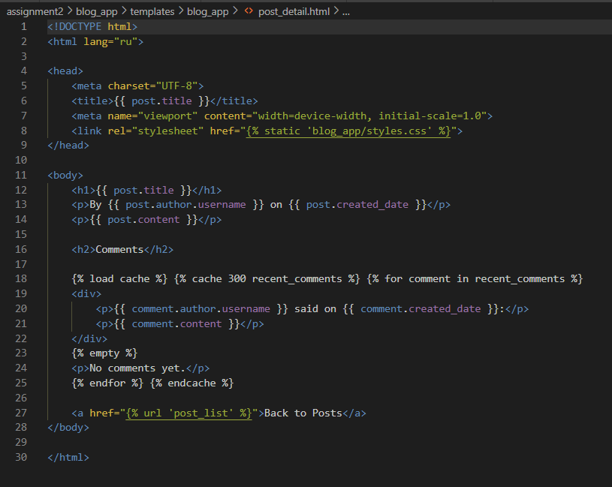

6. Dependency Management

6.1 Virtual Environments

To manage dependencies, it’s recommended to use a virtual environment:

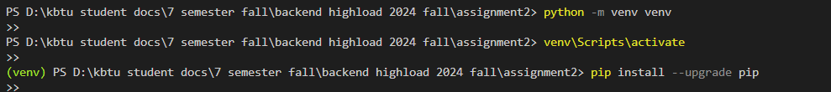

6.2 Project Structure

Django project structure will look like this:

7. Working with Database

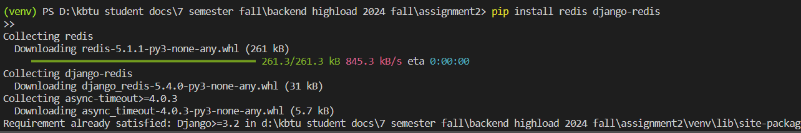

Redis was downloaded to work with databases

8. Connecting with Frontend

8.1 API Endpoints

Creating RESTful API endpoints in Django can be done using Django REST Framework. Here’s an example of a simple API view for fetching posts:

8.2 JSON Handling

Django handles JSON serialization with ease, allowing for seamless data exchange between the frontend and backend.

9. Conclusion

The Blog Application successfully integrates Django's powerful features for backend development, providing a robust and efficient platform for managing blog posts and comments. The project demonstrates best practices in database management, templating, and API development, paving the way for further enhancements and features.

10. References

Django Documentation: https://docs.djangoproject.com/

Django REST Framework Documentation: https://www.django-rest-framework.org/

Python Official Documentation: https://docs.python.org/3/